**Lab 2**

Ques1 BACKLOG-2 FROM sp.nathanielgmartin.com based on key sensing and control statements.

A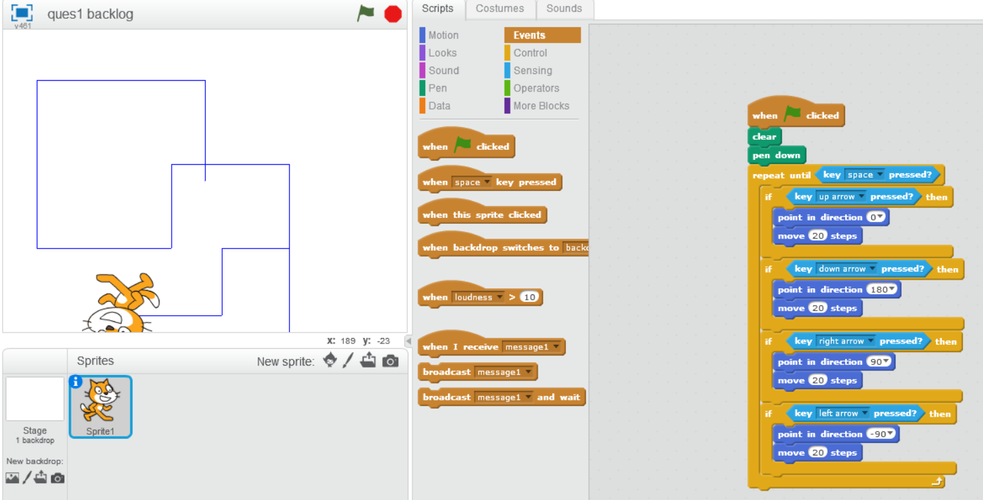

B

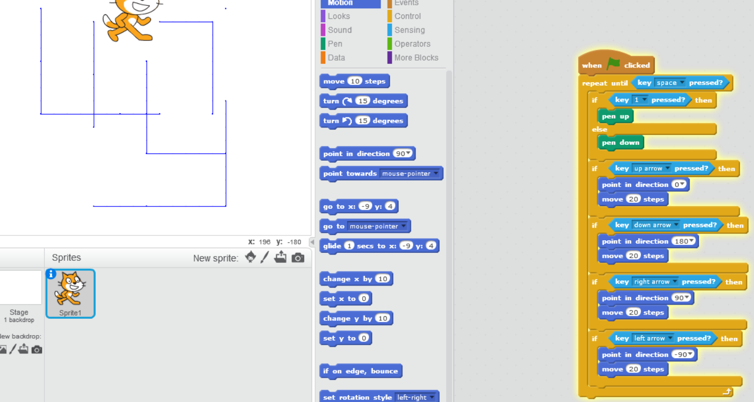

Ques 2 Make the sprite walk back & forth normally using the option set rotation style option from motion pallete. We do not want it to go upside down!

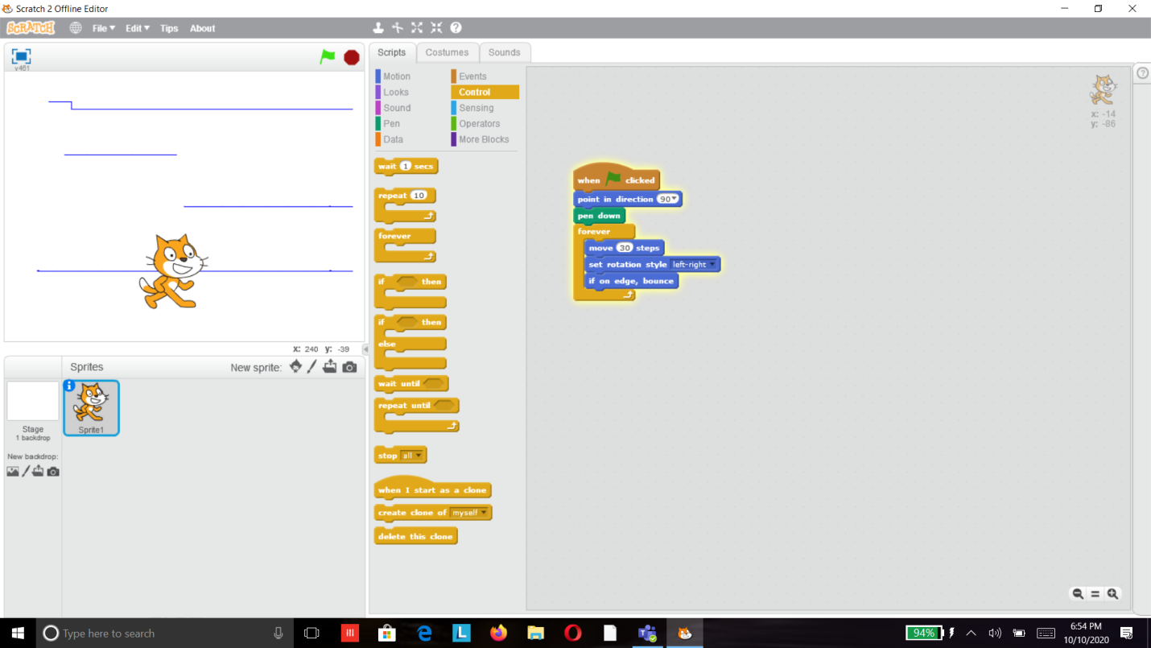

Ques3 Move your sprite 30 steps forever on stage but when it touches the edge of the stage it should bounce back.

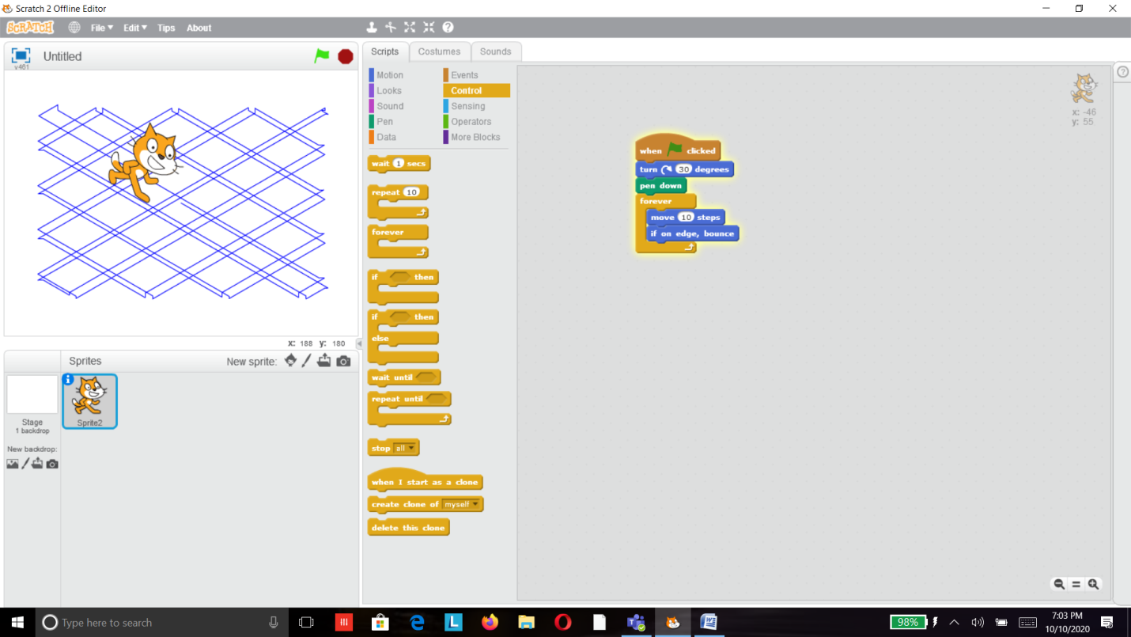

Ques4 Turn your sprite 30 degree and move your sprite 10 steps forever but if it touches the edge it should bounce at all edges.

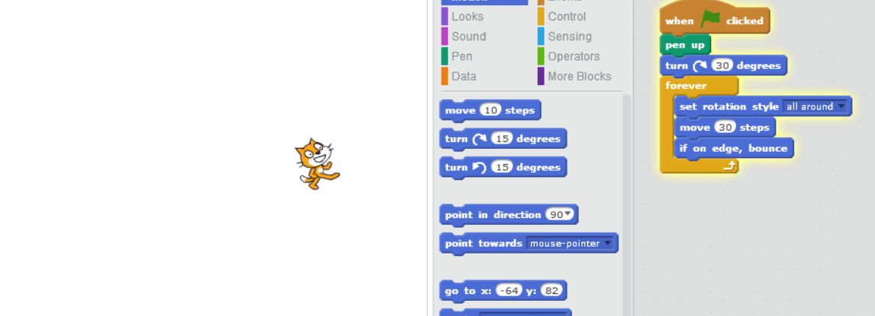

Ques5 Trace all the path as it is moving in program no. 4 using blue color.

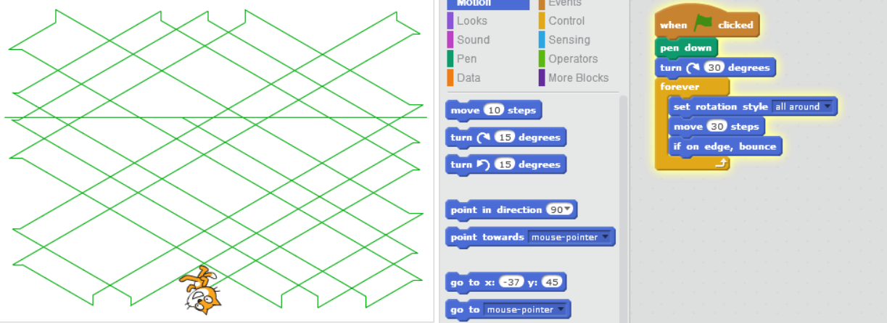

Ques6Trace all path as it is moving  all round (use the option-set rotation style option from motion palate) in program no. 4 but trace the path with different color starting from blue .Choose the option change pen color-1 option from pen

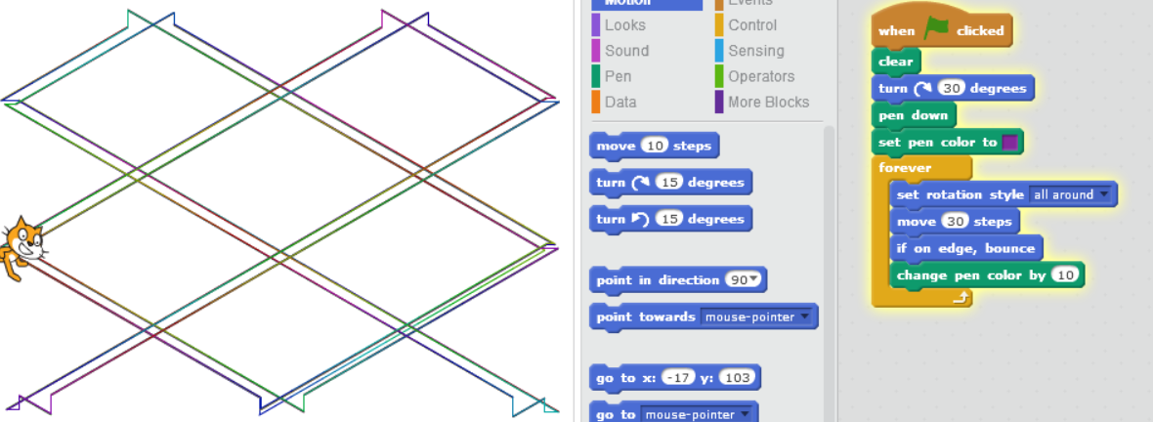

Ques 7 As the sprite in moving in program no. 4 sprite should be stamped on the path on the stage .set the sprite size to 50%

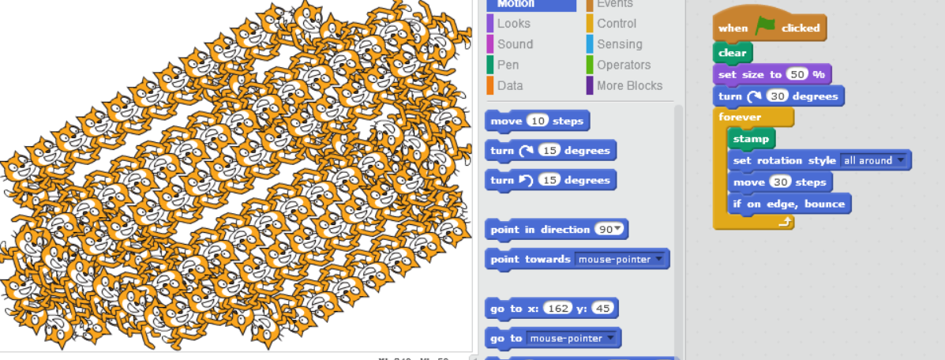

Ques8 We want a big circle of sprite so repeat the steps 24 times to create a circle of sprite as shown in the picture.

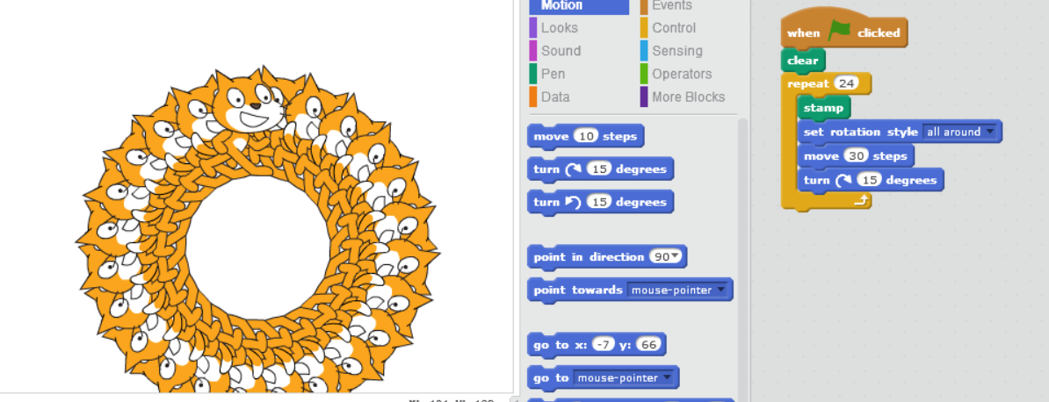

Ques 9 Make the sprite roll while changing color and playing sound. Let us trigger the block of code to run when space key is pressed.

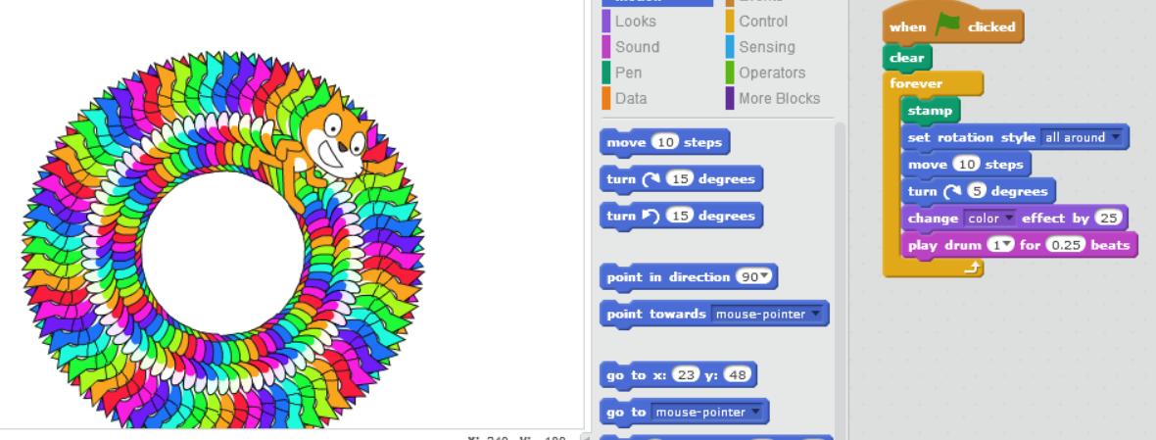

Ques10 Multi-size cat problem! Cats keep growing until you press s! Then, it becomes small, but they start growing as soon as you release s key.

